Application Form 

SECTION 1: INSTRUCTIONS
- Complete the application form and attach certified copies of your Identity Document and Matric Certificate or N3 Certificate.
- Pay the R250 non-refundable application fee and late application fee is R350. Important: Use your ID number as reference when making a payment. Payment must only be made into FDA’s bank account. No cash will be accepted by FDA or its representatives.
- Submit the completed application form, certified documents and proof of payment of application fee to FDA Administration Office.
Email: info@funulwazi.co.za
- FDA will notify you once your completed application has been received.
- FDA will notify you if your application was successful and issue you with an Acceptance Letter which must be completed, signed and returned to FDA.
- The registration fee due must be paid before the last payment dates specified in the Acceptance Letter.
- You will be registered at FDA upon receipt of your signed Acceptance Letter and proof of payment of the registration fee. Registration form will be sent to you for completion.

SECTION 2: THE PROGRAMME APPLYING FOR
Occupational Certificate: Chemical Laboratory Analyst, NQF Level 4, 200 credits

SECTION 3: PERSONAL DETAILS
Title:
Surname:
First Names:

Date of Birth:
ID Number:

White

Male
Female

Race: African

Indian

Coloured
Gender:

Home Language:

SECTION 4: CONTACT DETAILS
Residential Address:

Postal Code:

Nearest Town:

Province:
Postal Address:
Postal Code:

Cell Number: Email:

Work Tel. No:
Home Tel. No:

SECTION 5: EMPLOYMENT DETAILS (If applicable)
Province:
Name of Employer:
Work Tel. No:
Your Position:
Employment Status: Full Time Part Time
Address of Employer:
Postal Code:

Title:
Postal Code:
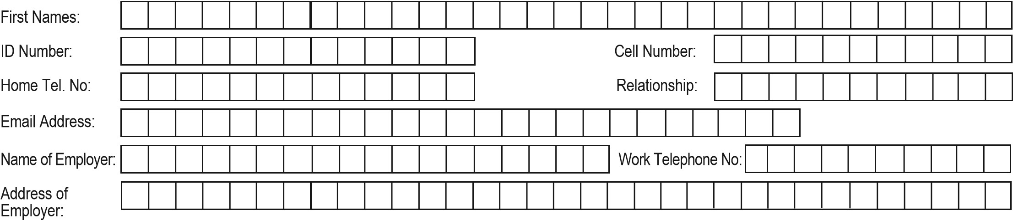
SECTION 6: NEXT OF KIN Surname:

SECTION 7: DISABILITY STATUS
Please specify your disability rating for each of the following below:
Disability Type | Communicating | Sight | Hearing | Self-Care | Remembering | Walking
No difficulty
Some difficulty
A lot of difficulty
Cannot do at all

SECTION 8: CRIMINAL RECORD
Do you have a criminal record: Yes No
Take note that you will not be able to practice as a teacher should you have a criminal record at the time of completing your qualification.

SECTION 9: DECLARATION
I, the undersigned, by my/our signature hereto consent, warrant and agree that:
I am aware that the number of applications received may outnumber the spaces available at the institution. Therefore, meeting the minimum requirements for the application does not guarantee admission to the institution.
If my application is successful and I accept the opportunity to study at FDA,
1. I declare that:
1.1 I will comply with the Student Code of Conduct stipulated by FDA.
1.2 I shall inform the Administration Office immediately, in writing, if I change/amend any part of my personal and/or contact details.
1.3 I have acquainted myself with the information in the prospectus and on the FDA website, including Recognition of Prior Learning (RPL) that relate to the qualification for which I am applying.
- It remains my responsibility to have an active email address to ensure that I receive communication from FDA through this medium.
- I hereby accept liability for the payment of all tuition fees or other fees which may be charged by FDA as a result of my studies at FDA as described in the prospectus.
- I am aware that my enrolment is valid only if it complies with the regulations of the qualification concerned, notwithstanding the acceptance of this application by FDA.
- I accept the responsibility of submitting all documents required by FDA before the due dates.
- I declare that the information contained herein is true and correct and FDA shall be entitled to cancel my registration if I have made any misrepresentation or omission on this application.
- I acknowledge that my residential address will be the main indicator for venue allocation pertaining to academic support sessions.
Signature of Applicant: __________________________ Date: _____________________
To be completed with the assistance of Parent/Guardian/Spouse where applicant is not financially independent and/or under the age of 18 years (a minor)
I declare that: I make this application and give the declarations and understanding with the knowledge and consent of my Parent/Guardian or Employer (if applicable).
Signatures
Applicant: _____________ Parent/Guardian/Employer: ______________________
Date: _____________________ Date: ____________________________

SECTION 10: BANKING AND CONTACT DETAILS
Please make all payments in favour of:

Account Holder: Funulwazi Development Academy
Account Number: 6274 3977 962
Bank: First National Bank
Bank Branch: Davenport
Bank Code: 250 655

Note:
Please use your Name and Surname as a reference when making payment at the bank.

